CHAPTER – 1
INTRODUCTION
Chapter 1: Introduction
1.1 Introduction
CargoSync is an innovative, cloud-based logistics and fleet management platform engineered to bridge the gap between companies requiring freight transport (shippers) and available truck operators (carriers). Beyond functioning as a marketplace, the platform integrates smart automation to resolve critical, error-prone bottlenecks in physical delivery: payload capacity planning, routing execution, and chain-of-custody verification.
1.2 Problem Statement
Traditional freight logistics and local physical delivery ecosystems suffer from acute inefficiencies due to disjointed workflows, manual planning errors, and lack of transparency. Key systemic problems include:
- Wasted Payload Capacity: Manual load planning leads to sub-optimal space utilization inside delivery trucks (3D bin packing inefficiencies).
- Inefficient Loading Sequences: Cargo is often loaded without considering the order of multiple drop-off points, forcing drivers to repeatedly unload and reload boxes mid-route to access specific items.
- Fragmented Capacity Sourcing: Small-to-medium shippers struggle to efficiently find nearby, vetted, available truckers matching their volume and weight needs.
- Unreliable Chain of Custody: The reliance on paper manifests and manual handoffs results in delivery disputes, cargo tampering, and delayed payout cycles due to unverified proof of delivery.
1.3 Scope and Relevance of the Project
CargoSync unifies booking, spatial optimization, fleet matchmaking, and end-to-end delivery tracking into a single digital ecosystem.
- Scope: The platform covers user registration (shippers and truckers), job posting with granular box-level attributes, an automated 3D optimization and routing backend engine, an on-demand marketplace matcher, a mobile-based QR scanner for drivers/recipients, and automated payment/dispute handling workflows.
- Relevance: In an increasingly on-demand economy, CargoSync drastically lowers operational overhead for shippers, increases earning potential and route clarity for truckers, minimizes delivery friction, and reduces carbon footprints by optimizing truck space and route miles.

1.4 Objectives
- To automate physical load layout planning using computational 3D bin packing algorithms.
- To optimize delivery routes using reverse delivery sequencing based on drop-off manifests.
- To establish a real-time, proximity-based matching marketplace for on-demand truck capacity.
- To implement an immutable, QR-code-driven digital chain-of-custody tracking mechanism from pickup to final recipient confirmation.

CHAPTER – 2
SYSTEM ANALYSIS
Chapter 2: System Analysis
2.1 Introduction
This chapter evaluates the current paradigm of freight logistics, highlights the operational gaps that CargoSync addresses, and establishes the practical viability of deploying the proposed platform.
2.2 Existing System
The existing system relies on manual coordination, legacy standalone software (ERP spreadsheets), and paper-based documentation. Shippers book trucks via third-party phone brokers or rigid, long-term fleet contracts. Load arrangement is left to the visual estimation of warehouse workers or drivers.
Limitations of Existing System
- High Spatial Volume Volatility: High rates of underutilized volumetric space or accidental overloading.
- Route Friction: Excessive time spent at delivery stops due to disorganized cargo placement.
- Opaque Tracking: Lack of real-time transit visibility, leading to reliance on frequent, manual check-calls to drivers.
- Dispute Vulnerability: High rate of insurance claims and payment delays due to lost, damaged, or unverified item transfers at delivery handoffs.
2.3 Proposed System
The proposed system, CargoSync, replaces human error with algorithmic precision. Shippers enter box-level dimensions and sequence parameters into a cloud portal. The engine immediately outputs exact loading configuration instructions and coordinates with an integrated on-demand carrier marketplace. Real-time validation is strictly enforced at every touchpoint using QR scanning on a mobile application.
Advantages of Proposed System
- Maximizes truck spatial utilization automatically.
- Eliminates mid-route unloading delays via reverse sequencing.
- Speeds up capacity procurement through proximity and rating-based automated matchmaking.
- Ensures verifiable, timestamped, and tamper-resistant chain-of-custody data.
2.4 Feasibility Study
Technical Feasibility
The platform utilizes established, highly accessible web and mobile technologies. The 3D bin packing and routing algorithms can be effectively processed via cloud computing infrastructure (e.g., AWS/GCP). Mobile devices with built-in cameras provide sufficient hardware support for the QR-scanning framework, making the system technically feasible.
Operational Feasibility
The platform features an intuitive interface tailored to the distinct workflows of two main user profiles: warehouse managers/shippers and on-the-road truck drivers. Because it streamlines heavy administrative and physical loading burdens, user adoption barriers are minimal, proving operationally feasible.
Economic Feasibility
The system follows a scalable Cloud-SaaS model. The initial development and maintenance costs are heavily offset by immediate savings: reduced fuel expenses via route optimization, minimized cargo loss liabilities, and transactional commission revenue generated from market matchmaking. Therefore, the project is highly economically feasible.

CHAPTER – 3
SYSTEM DESIGN

3.1 Introduction
The system design for this project revolves around creating a centralized platform that integrates fleet management, cargo booking, and logistics optimization for trucking and freight operations. At its core, the architecture consists of a frontend interface that enables smooth registration, fleet onboarding, and access to booking and tracking dashboards, along with a backend system that manages user data, job scheduling, and real-time cargo operations. A robust relational database supports structured information like trucks, jobs, and bookings, while computationally intensive processes such as 3D bin-packing and route sequencing are handled by a dedicated optimization engine to ensure efficiency.
Functionally, the design is divided into modules that cover authentication, fleet management, booking, cargo management, marketplace matching, optimization, loading plan generation, chain-of-custody scanning, live tracking, payments, ratings, and analytics. Fleet operators can register trucks, manage jobs, and generate optimized loading plans, while shippers can book cargo space and track shipments in real time. The optimization engine computes efficient 3D bin-packing and reverse delivery sequencing, while marketplace and trust features like ratings and chain-of-custody verification enhance transparency between shippers and carriers. This modular approach ensures that each aspect of the logistics workflow—booking, loading, transport, and delivery—is supported within one integrated ecosystem.
From a non-functional perspective, the system emphasizes scalability, security, performance, and usability. It is designed to handle growing fleets and booking volumes, ensuring smooth interaction across distributed operations. Security measures like authentication and encryption safeguard company and shipment data, while performance optimization guarantees fast responses during packing computations and live tracking updates. The intuitive interface ensures accessibility for both fleet operators and shippers, making the platform a dynamic and reliable environment for freight logistics.

3.2 UML Diagrams
ER Diagram
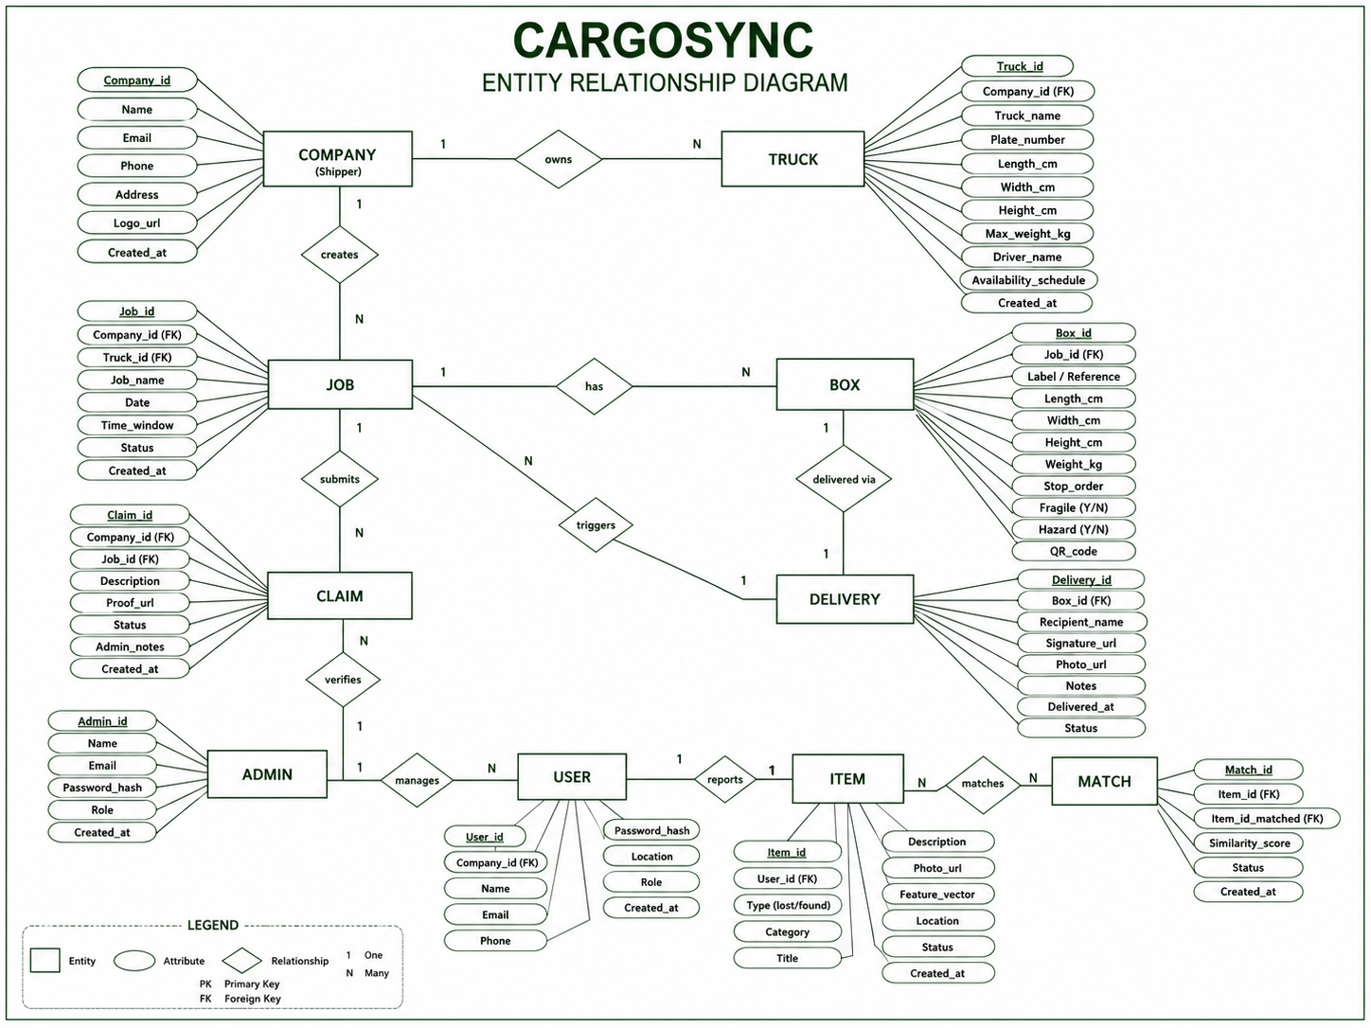

Activity Diagram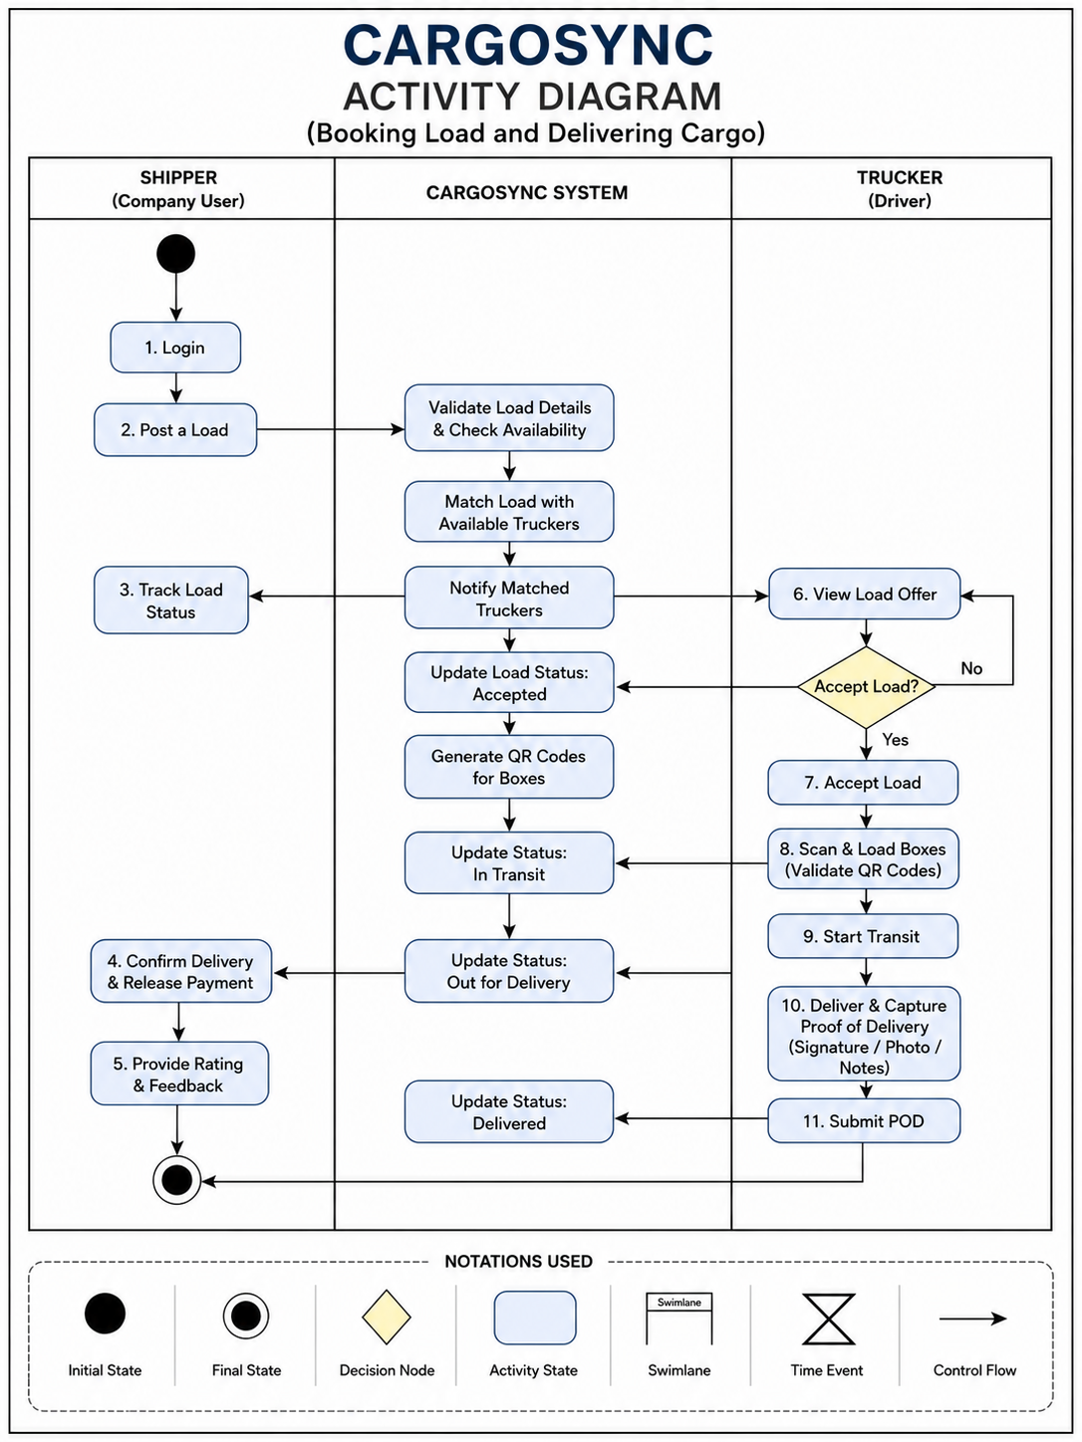

Use Case Diagram
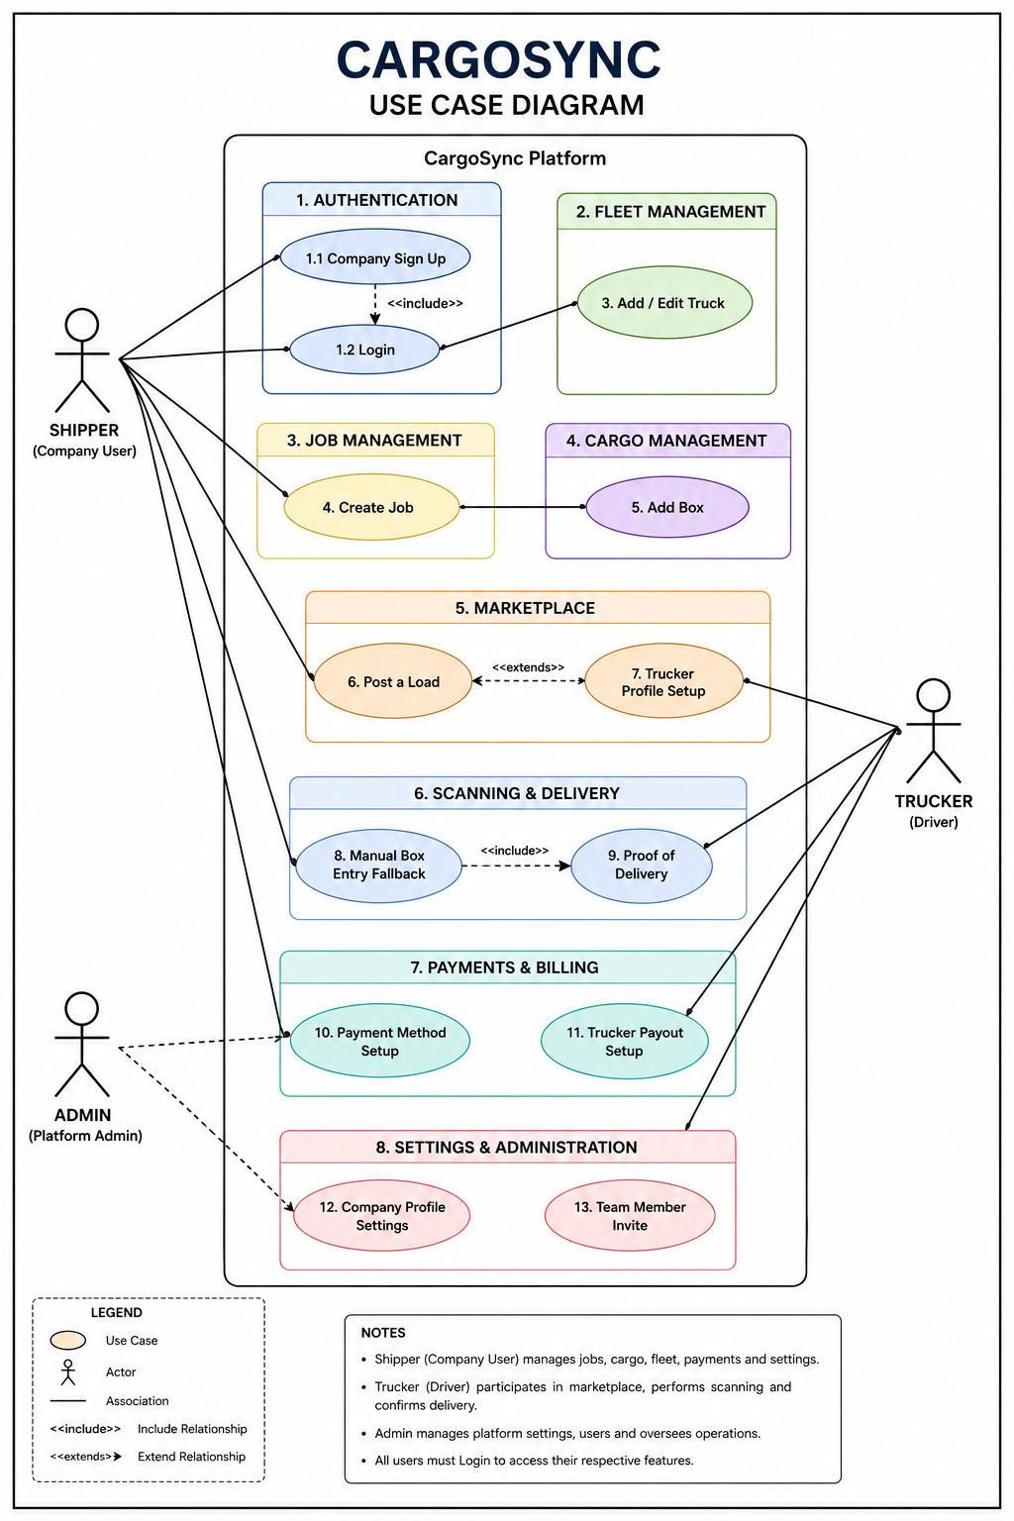

Sequence Diagram
